**Dhruval P. Kumavat**  **230340325010**

Q1.

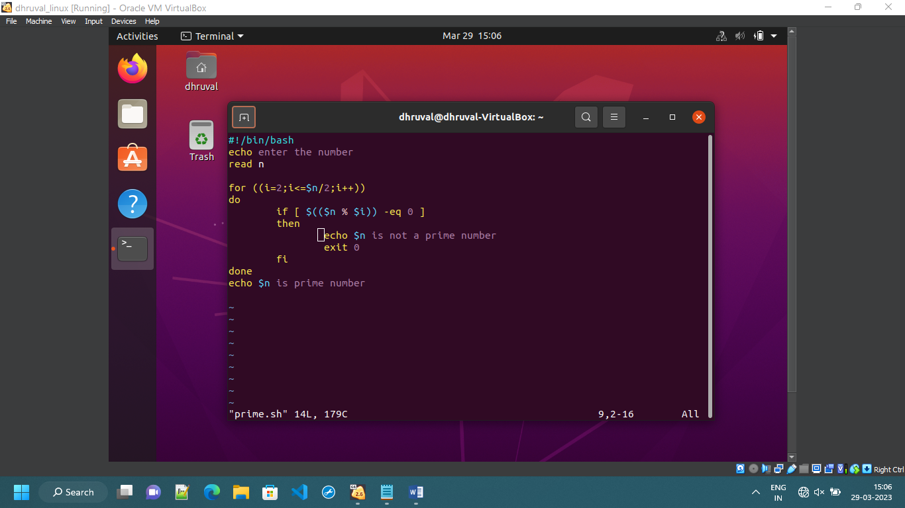

OUTPUT:

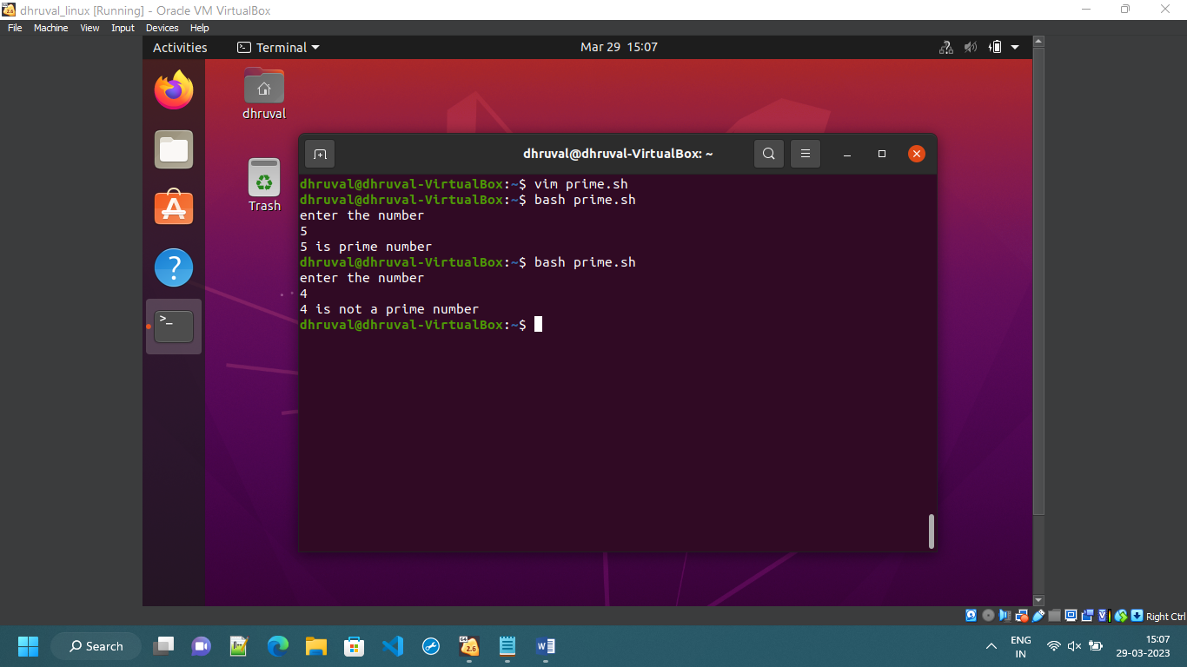

Q3.

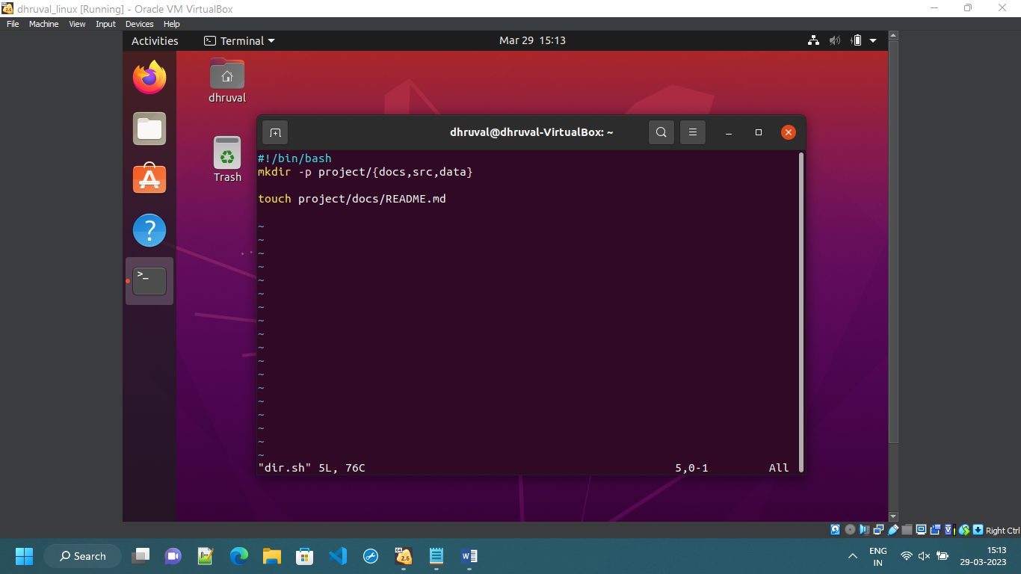

OUTPUT:

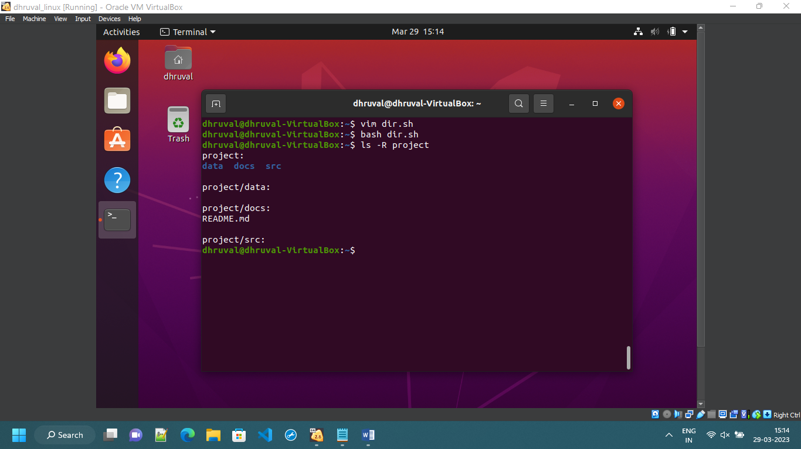

Q4.

OUTPUT:

I had created a instance name Dhruval

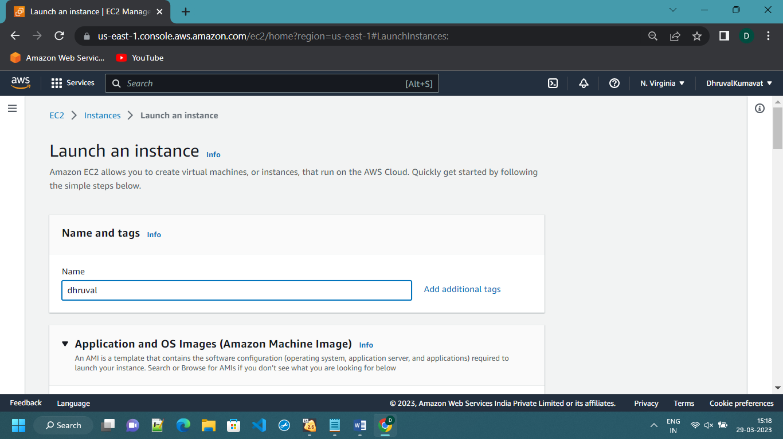

For that instance, I have created a key

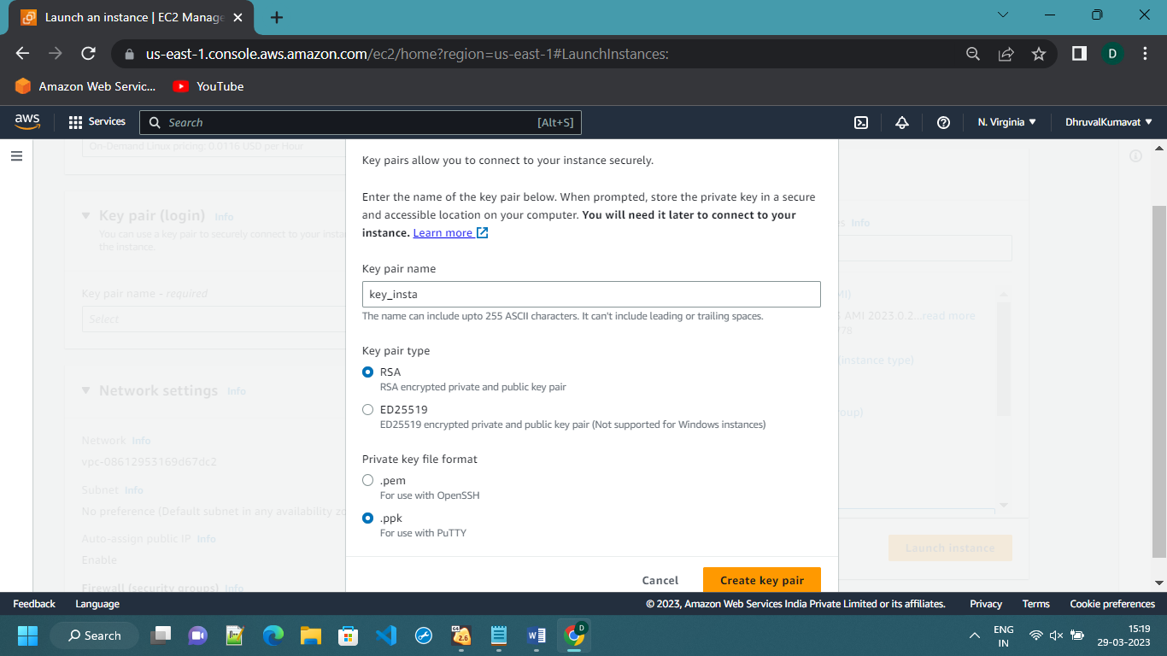

Then I have changed only required settings like allow HTTP traffic from internet rest are as it is

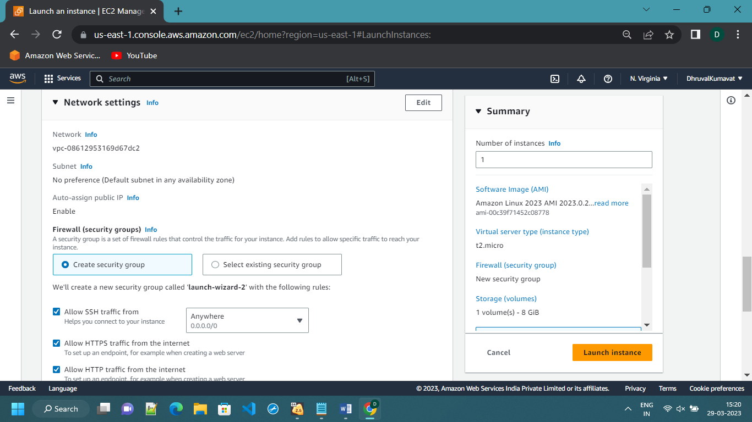

Then click on launch instance

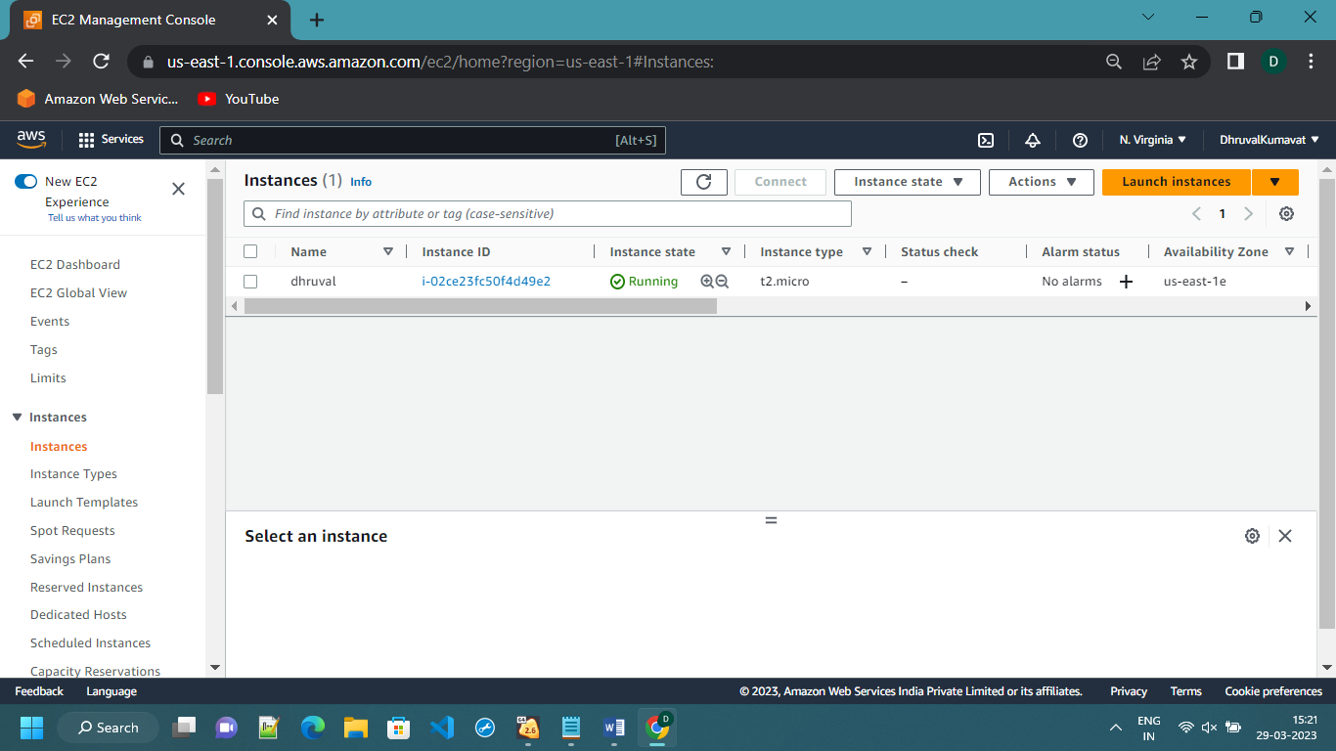

After launching of instance I have copied the ‘public IP’ of the instance

To paste it on putty.

Then I have given the key location to the putty.

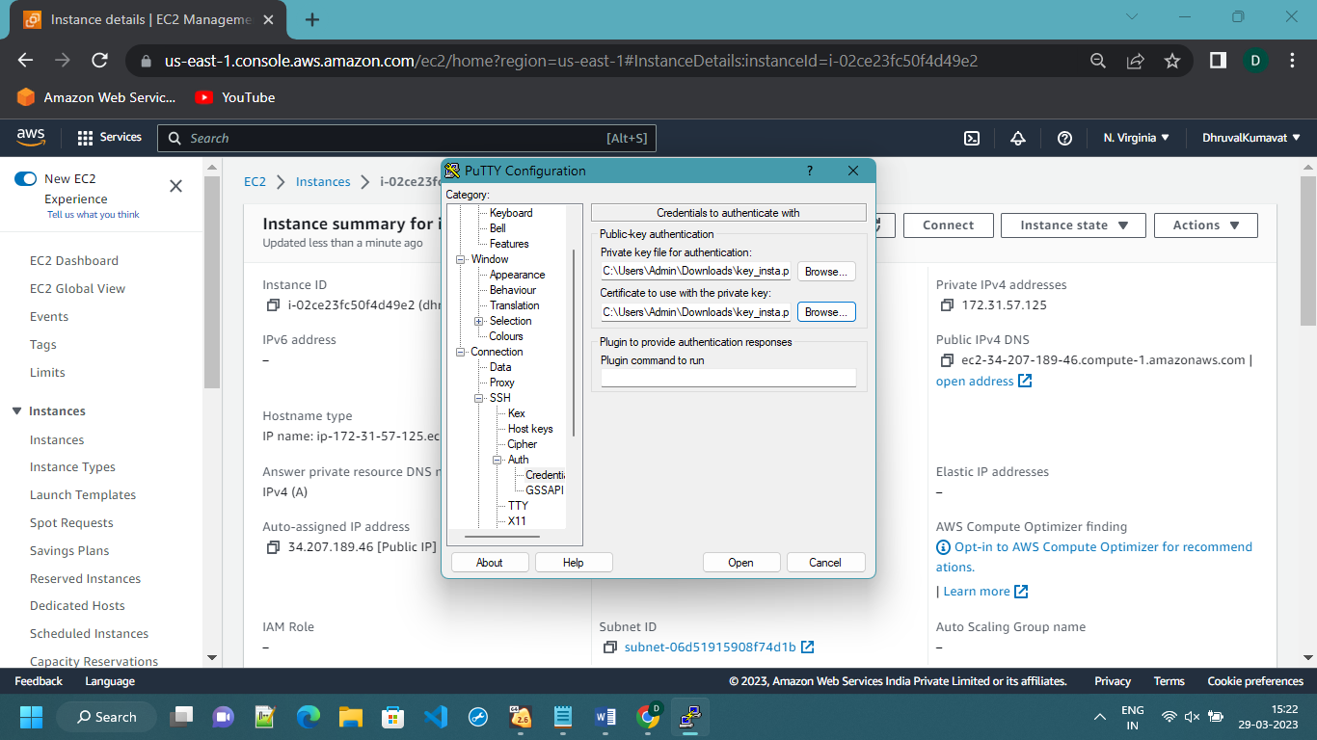

In putty I have executed following commands :

yum update –y

yum install httpd –y

systemctl start httpd

systemctl enable httpd

systemctl status httpd

cd /var/www/html

then I have created file as:

vim index.html

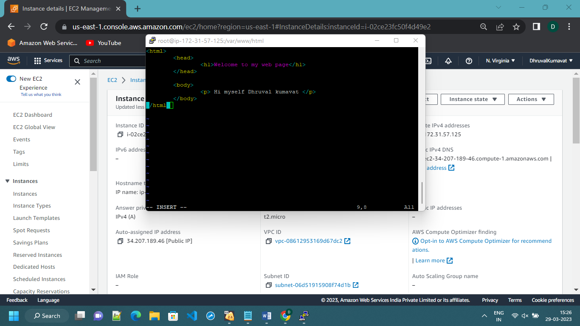

Then I have pasted the same public IP on the browser to check the output of the html file

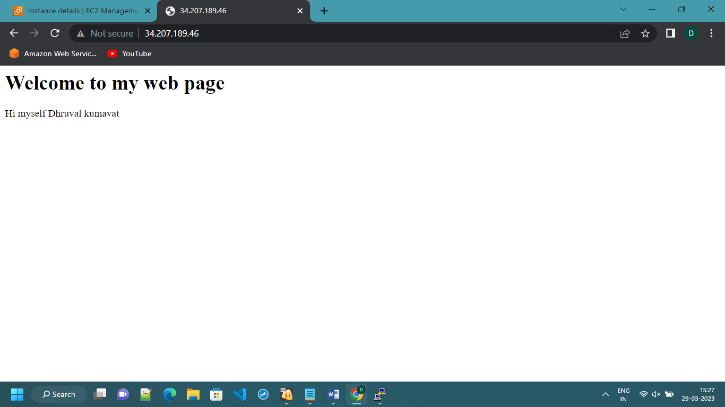

Q5.

Go to IAM page of the AWS website then click on user to create a user

Click on add user

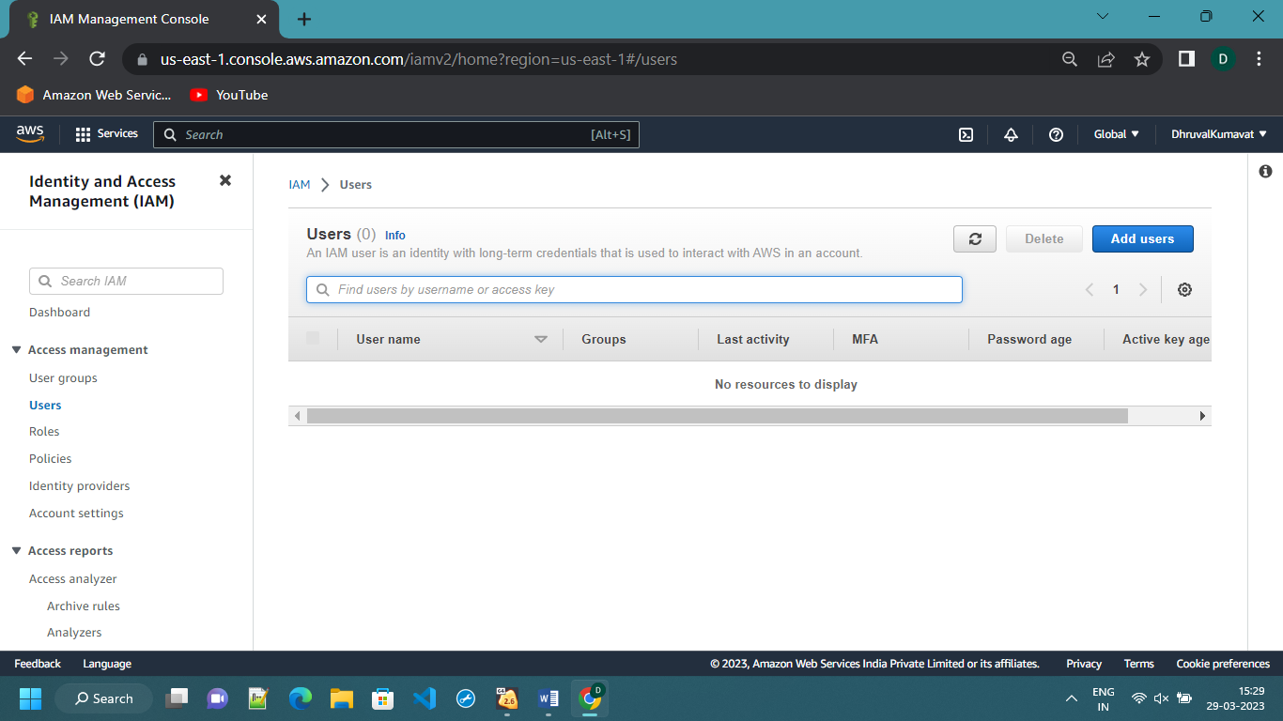

Give the user name

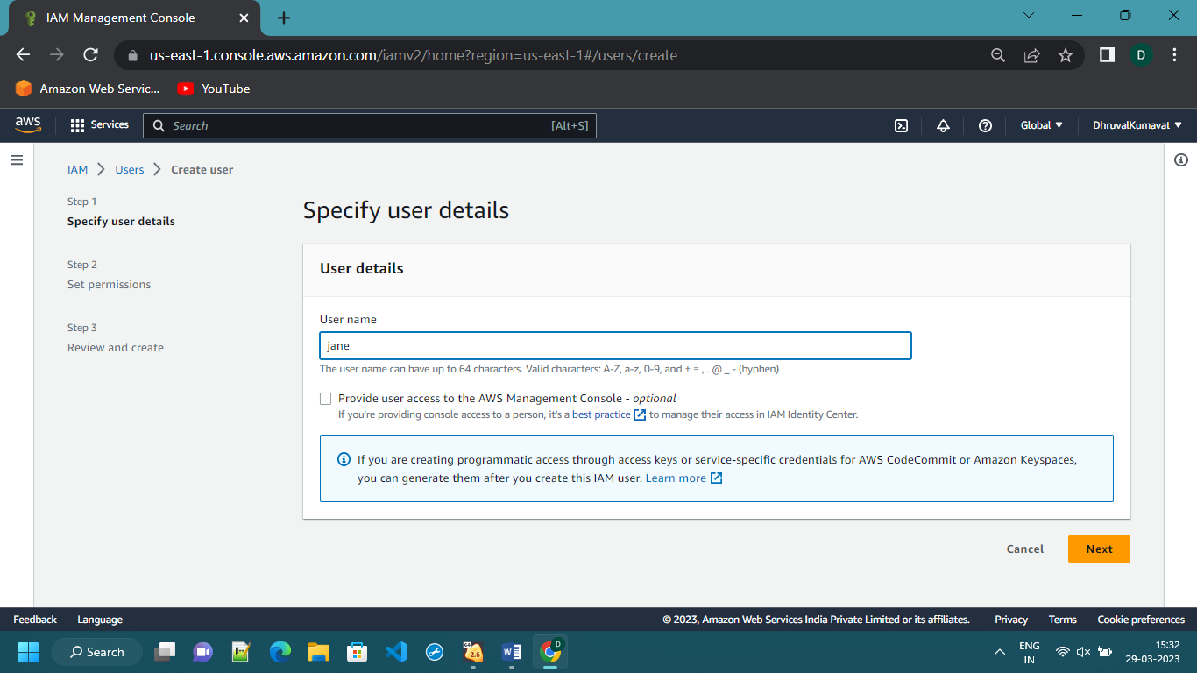

In permission I have selected the permission option of “Add user to group”

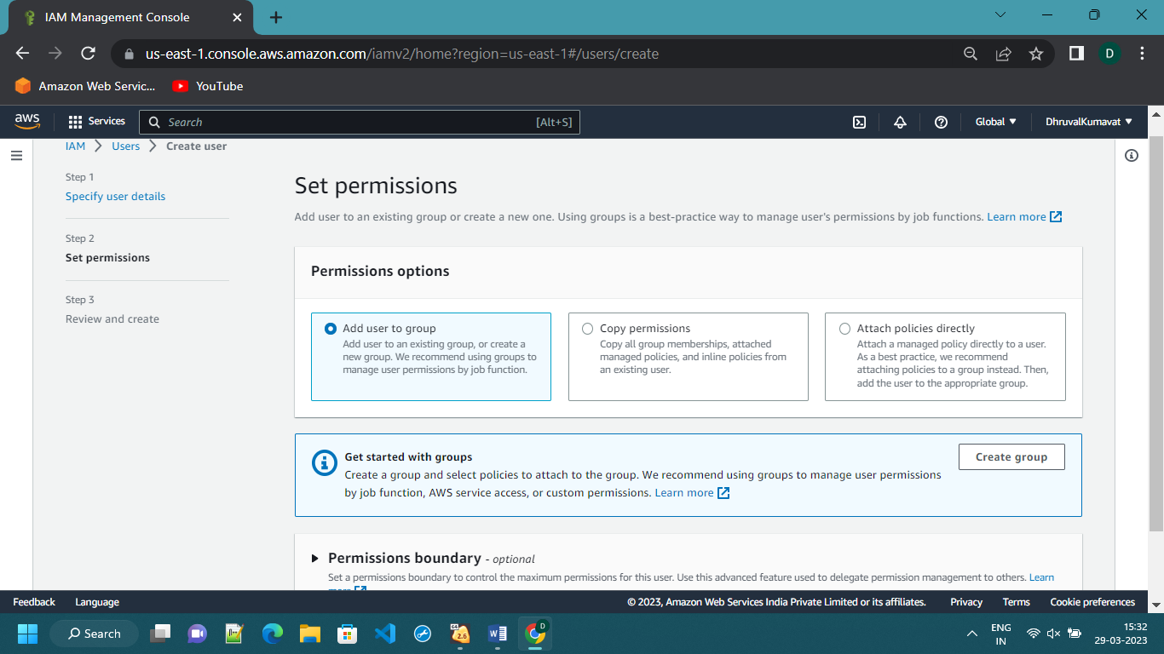

Then click on Next

Your user will be created

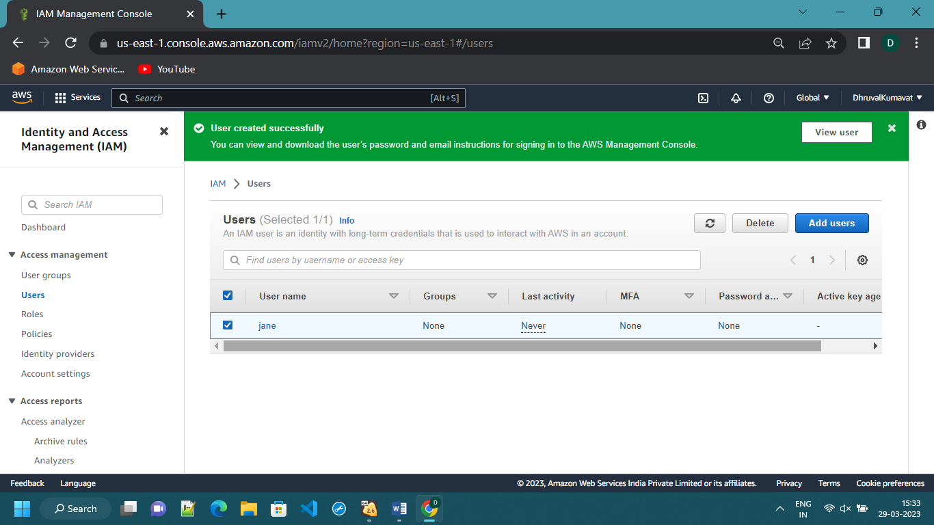

To add user in the group you have to create a group then add user in it

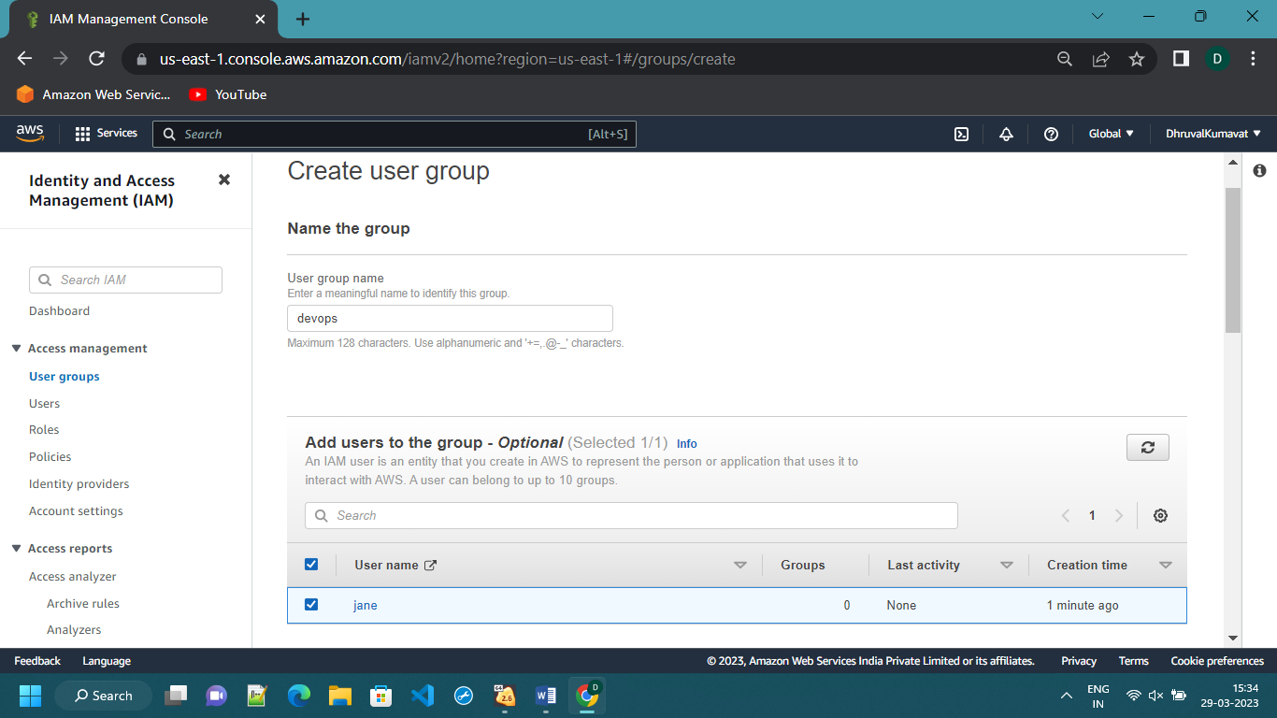

For giving the permission we will search for EC2 then we will give permission as follows

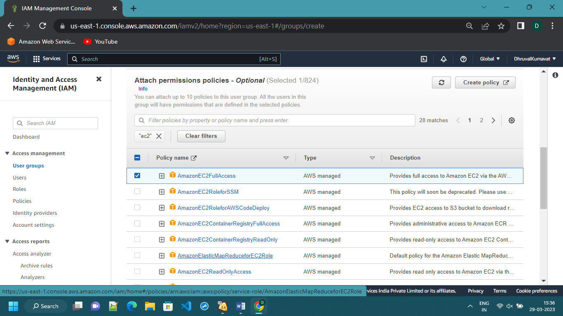

Then click on create group

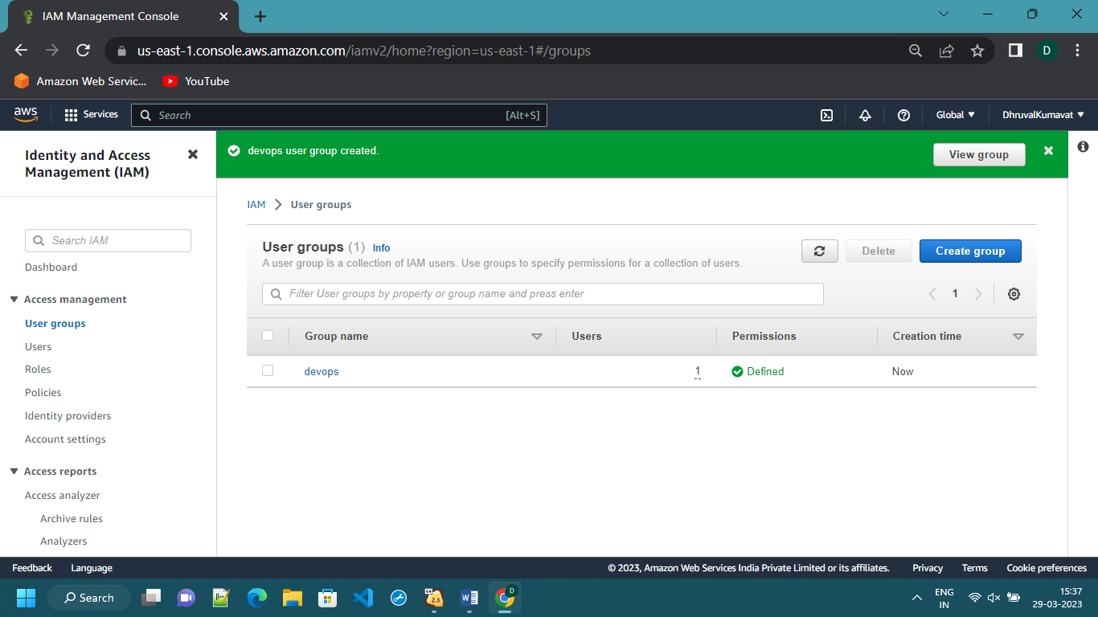

To check the permission policy we have to go to IAM policy simulator

This is IAM simulator in that I have selected user name ‘jane’

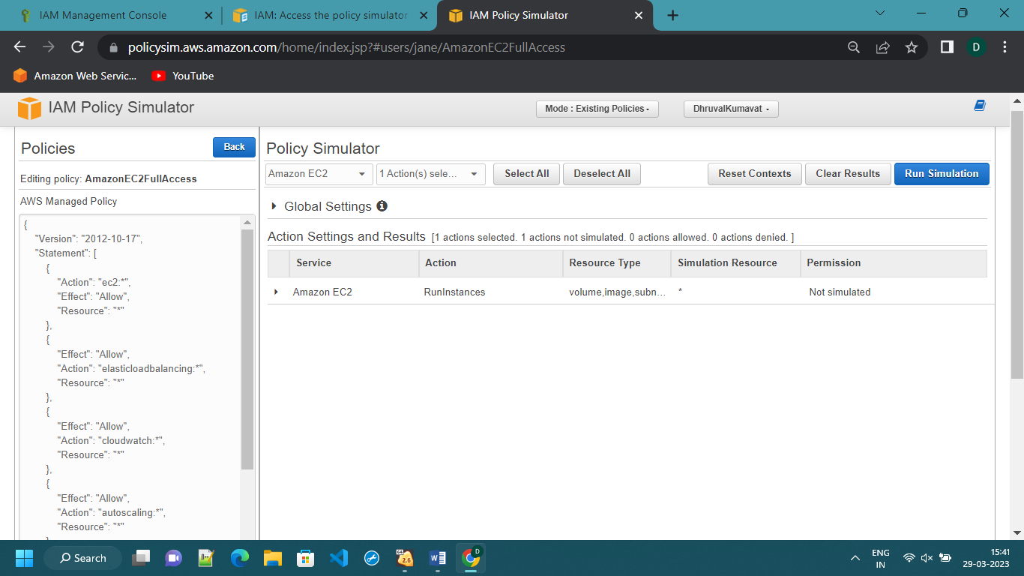

Select the required thigs and then click on run simulation

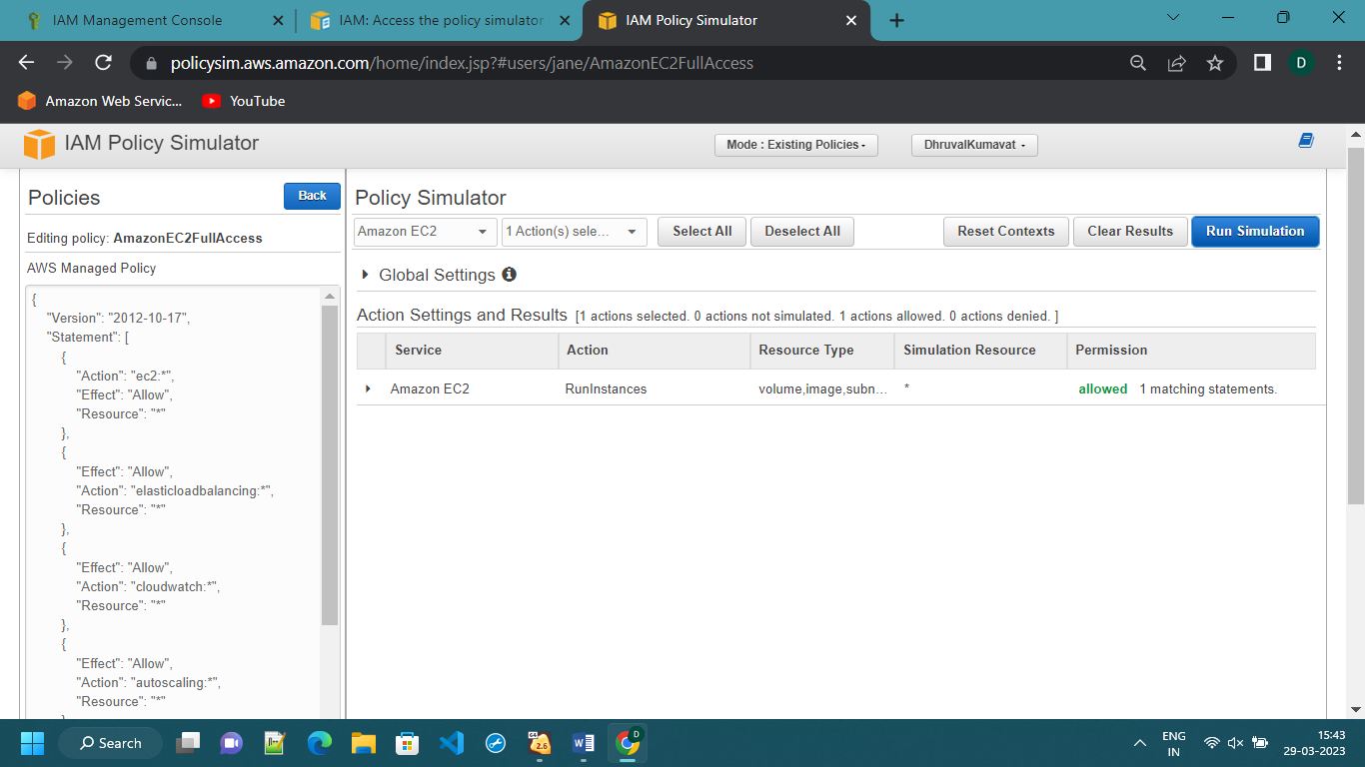

Then it will show you that the permission is given or not

To delete the user we select the user then click on the delete option

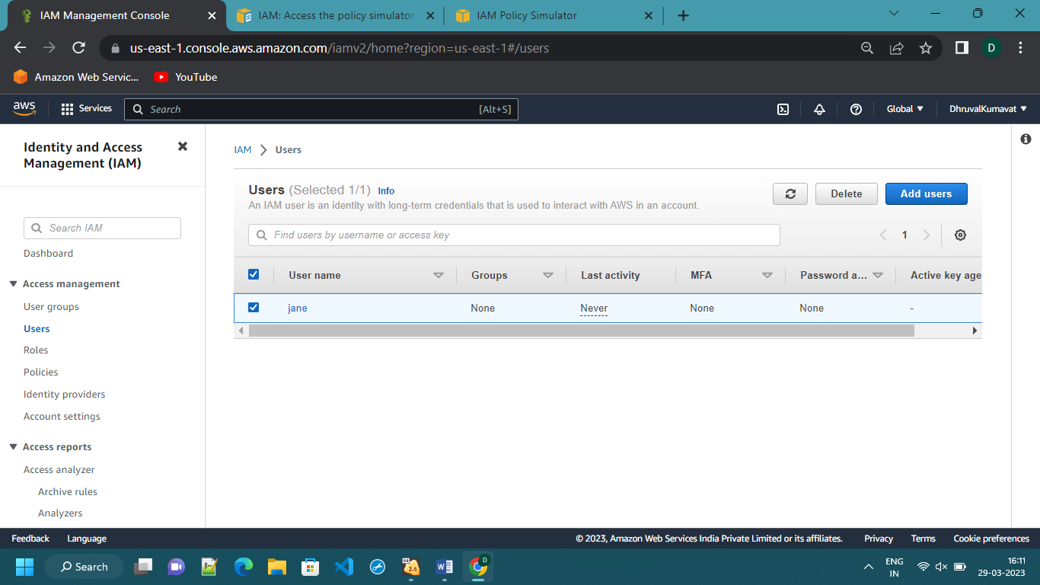

Then our user will be deleted

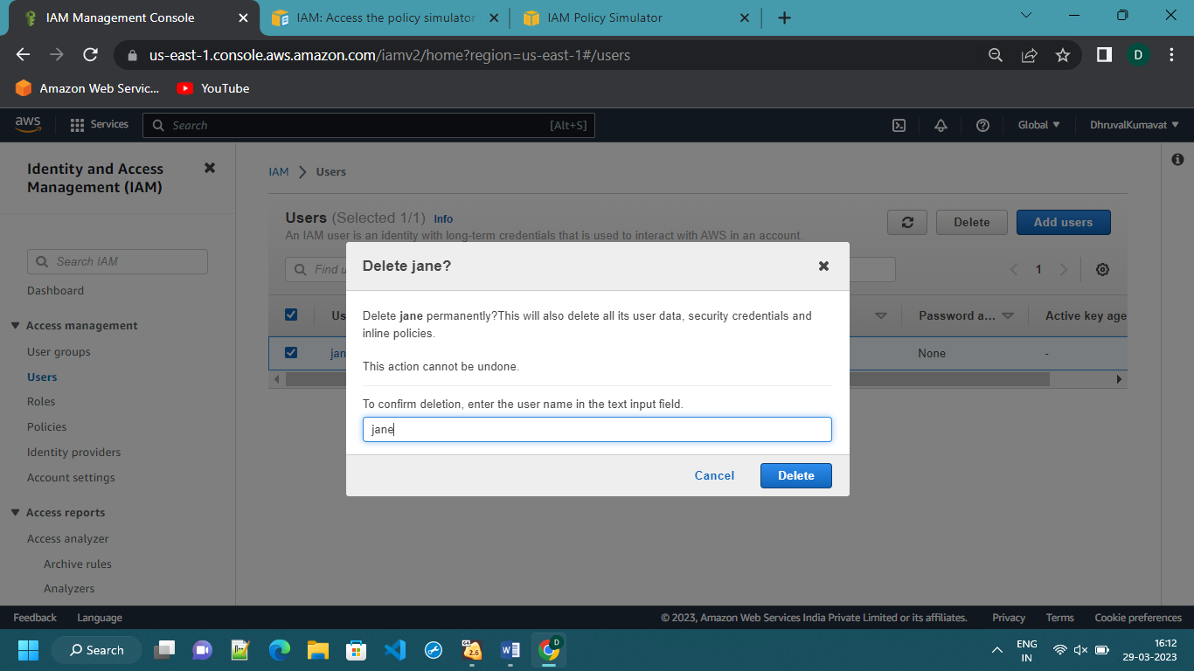

The user is deleted

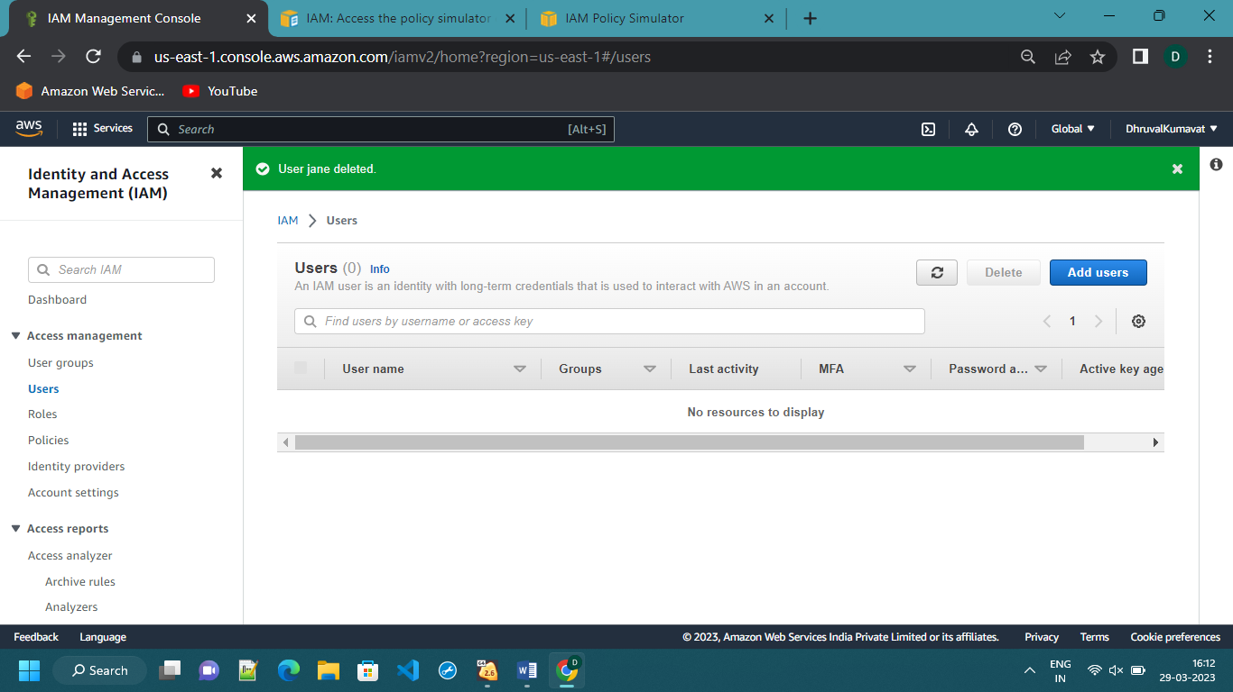

Same steps to follow for deleting the group

Select the group then click on delete option

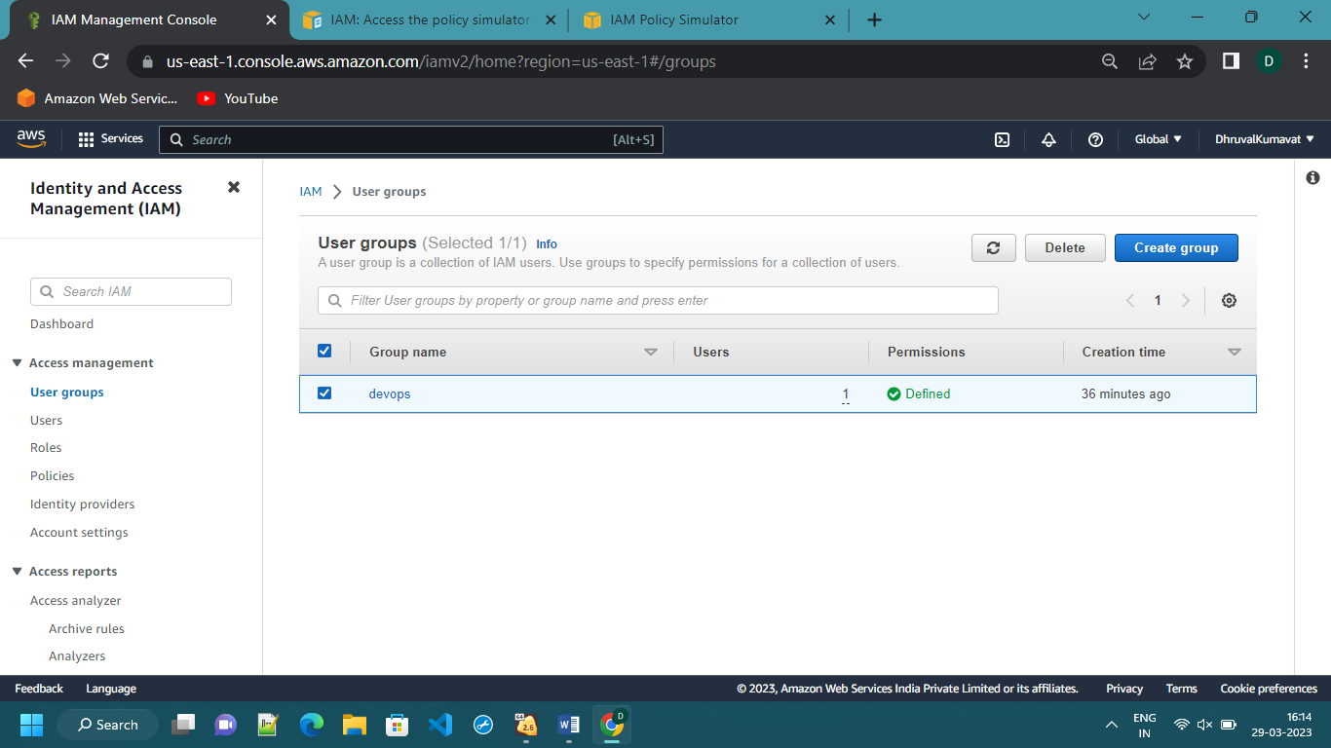

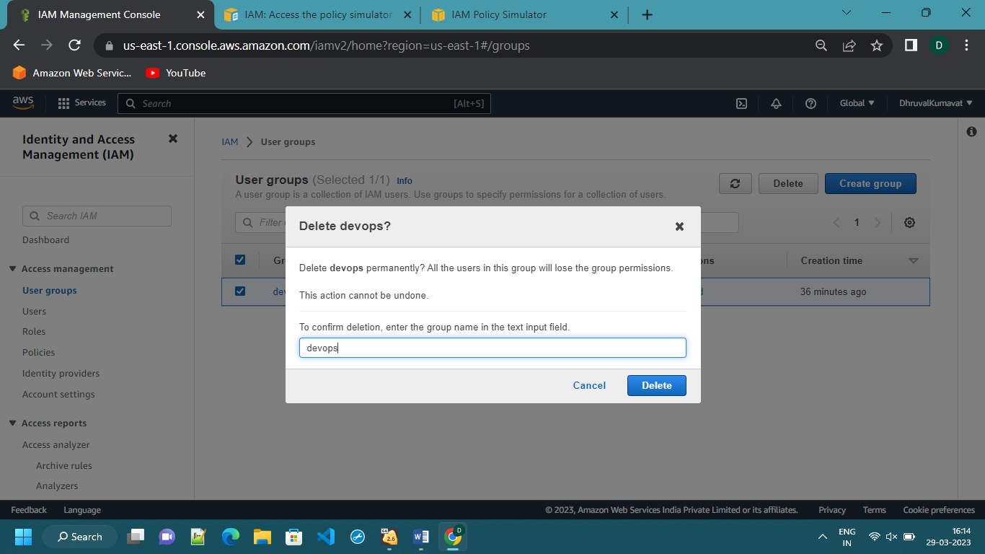

The group will be deleted

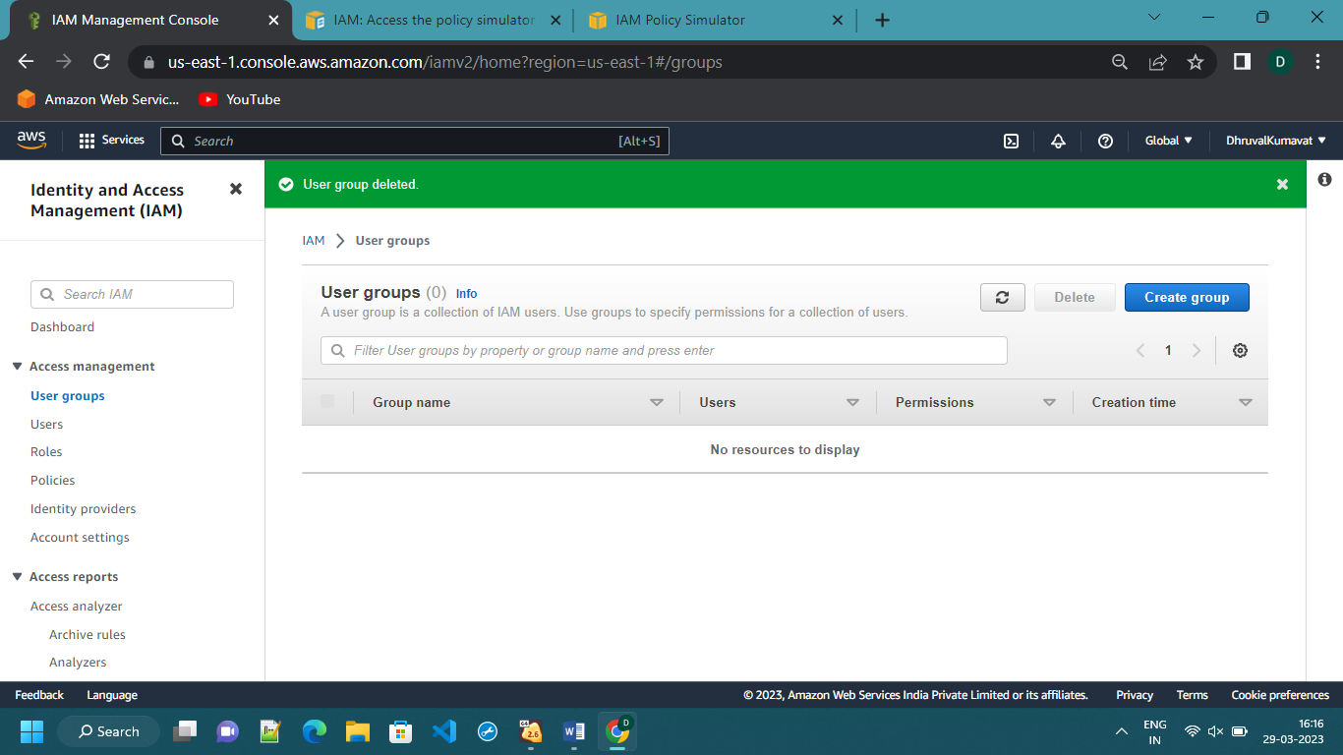

Q2.

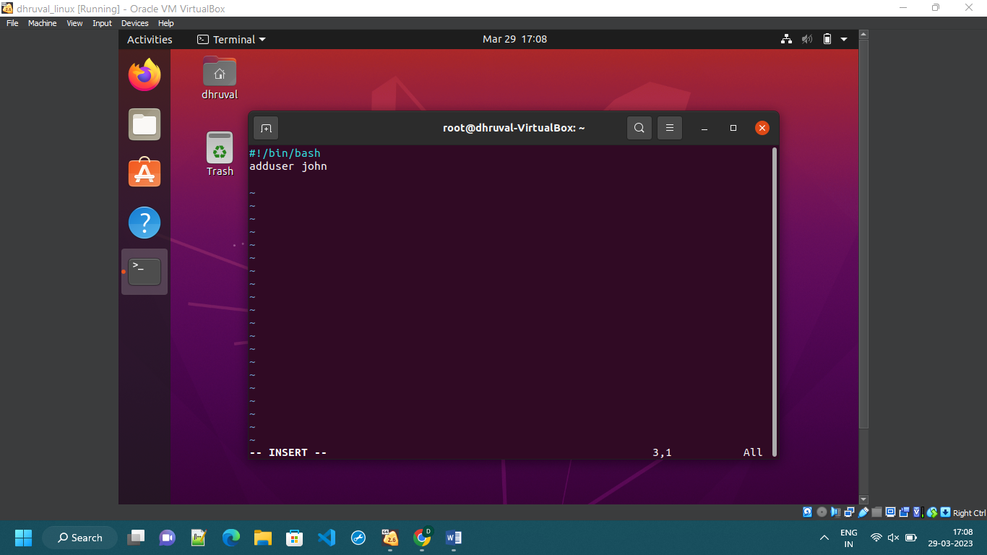

OUTPUT:

